Ultra High Performance Heat Pump by Using Water-Sorbing Heat Exchangers

Ruzhu Wang *, Yaodong Tu, Tianshu Ge

Shanghai Jiao Tong University, 800 Dong Chuan Rd. , Shanghai 200240, China
*Corresponding author, Tel & Fax: +86-21-34206548, E-mail: rzwang@sjtu.edu.cn

ABSTRACT

This research introduces an integrated heat exchanger with desiccant coating, named as water-sorbing heat exchanger (WSHE). When it is used as evaporator, air is cooled down by evaporation of refrigerant meanwhile dehumidified by the desiccant, the evaporation temperature could thus be controlled at about 15 ºC. When it is used as a condenser, the desiccant could be regenerated by condensing heat, heat transfer in condenser will be enhanced significantly due to this desorption process, thereby the condensing temperature is reduced to 40-45 ºC. By using a switch valve, refrigerant flow could be changed, thus the function of evaporator and condenser could be changed. The air flow could be also switched to fulfill the function of cooling-dehumidification or heating-humidification for space. Thus desiccant dehumidification will be fully undertaken by waste heat-condensing heat partly, the 40% cooling load will be handled as free. The remaining 60% sensible cooling load will be handled by high temperature evaporation. The desiccant is the key for this air handling unit, which should be regenerated with 30 ºC temperature difference. A packaged desiccant DX heat pump (DDX HP) by replacing ordinary fin-tube coils with WSHE, which could distinctly and simultaneously treat the sensible heat load and latent heat load. Experimental results showed that its thermodynamic COP was as high as 7.14 under the summer conditions per IOS 5151:1994, while its system COP is 6.2.

KEYWORDS: Water-sorbing heat exchanger, weak coupled heat and mass transfer, packaged desiccant DX heat pump
1. INTRODUCTION

Space cooling and heating need nearly 30% electricity consumptions worldwide, heat pumps (especially air source heat pumps) have been widely used for buildings, at most for residential applications. Duo to the demands of both sensible load and latent load, air conditioning usually are operated with the function of dehumidification, for which super-low evaporation temperature is needed to yield evaporator surface temperature be lower than the dew point (about 40% cooling load). Independent temperature and humidity control have been thought as a reasonable way to get high COP of sensible cooling with high evaporation temperature, but it need an independent desiccant dehumidification unit, which may need additional heat (electric or solar or any kind of waste heat) for regeneration, the combined system is thereby bulky and expensive.

The most reasonable way is to find a solution that sensible cooling and dehumidification could be integrated together in one heat exchanger, but the evaporation temperature of refrigerant could be high above the dew point of conditioned air. This will obviously increase COP and also supply comfortable air. As condensing heat is usually rejected to the ambient, if it could be used as a heat source for the regeneration of the desiccant, then the energy dissipation to the ambient will be greatly reduced, dehumidification will be energy-free.

2. HEAT PUMP BY USING WATER-SORBING HEAT EXCHANGERS

A novel vapor compression heat pump has been proposed recently as shown in Fig. 1a&b, in which solid/liquid desiccant is directly coated/sprayed to the outside surface of a conventional evaporator and condenser to forme the so-called WSHE (Fig.1c). When process air passes through the desiccant coated evaporator, the refrigerant inside can handle the sensible load while outside the coated desiccant realizes the removing of latent load. In this case, the processed air leaving the evaporator satisfies the requirement for supply air without overcooling or reheating (Fig.1d). On the other hand, adsorbent/absorbent can be regenerated in a desiccant coated condenser.

3. WATER-SORBING HEAT EXCHANGERS

Composite silica-gel-supported lithium chloride (CSGL) was selected as desiccant-needed, which adsorption capacity difference between a typical cooling/adsorption phase (80% RH) and a condensation/desorption phase (30% RH) is 0.34 kg kg⁻¹, more than twice that of silica gel due to the combination of capillary condensation and solution absorption (Fig.1f). In addition, the water-borne compound adhesive used as a binder. Meanwhile, it is easier to avoid corrosion or carryover of liquid droplets by controlling the salt content [2] and to prevent saturation or leakage by adjusting the duration of the moisture uptake process. The optimal coating thickness is approximately 10% of fin space based on our experience.

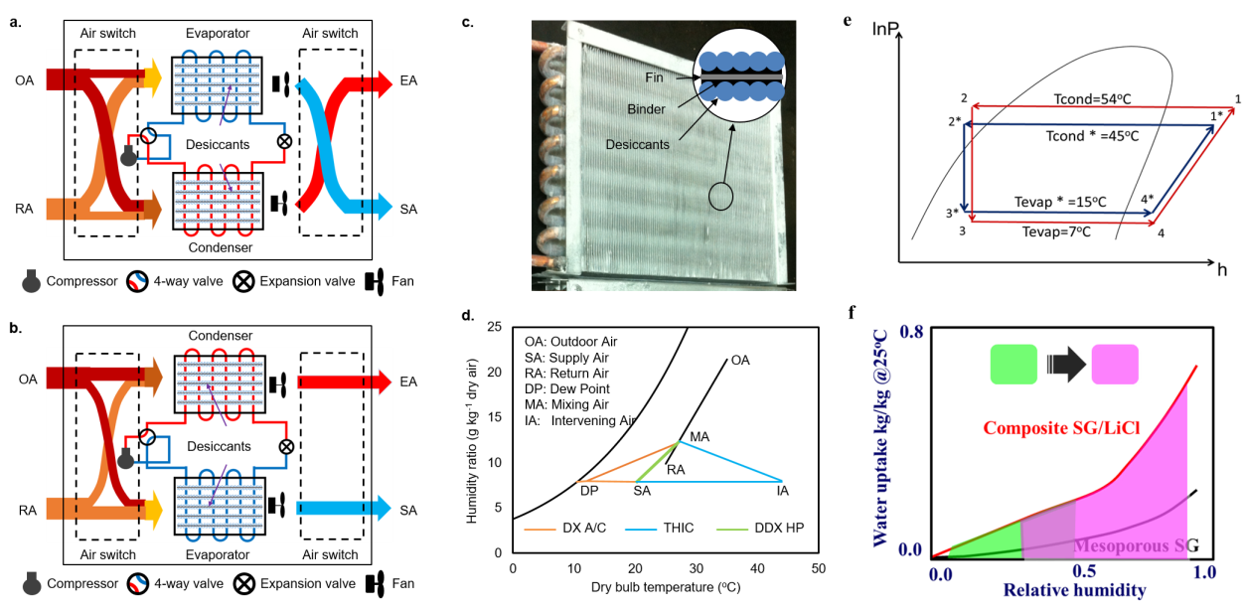
Figure 1: Schematics of DDX HP: working principle (a,b), photo of WSHE (c), air handling process (d), VC loop (e) and effects of WSHE on adsorbent (f).

WSHE shows a beneficial airside characteristic of weak coupling of heat and mass transfer. More concretely, the sensible load capacity is the same as that of baseline depending on the temperature difference between processing air and WSHE, while the latent load capacity can be enhanced dramatically relying on not only heat-exchanger temperature but also on the duration of the cooling/adsorption process. So, a temperature and humidity loosely-coupled control (THLC) strategy was developed: firstly, the required supply air temperature is adjusted by controlling the evaporation temperature and, secondly, the exit humidity ratio can be easily controlled by adjusting the duration.

A packaged desiccant-enhanced DX heat pump by replacing ordinary fin-tube coils with WSHEs has been designed to demonstrate the proof of concept. Experimental results showed that the evaporating temperature is increased from 5-7 ºC to 15-20 ºC, and the condensing temperature is reduced from 50-55 ºC to 40-45 ºC (Fig.1e). Its thermodynamic COP was as high as 7.14 under the summer conditions, while its system COP is 6.2. According to our knowledge, it is the first time that an approach can offer more comfortable supply air, doubled energy efficiency and 50% load capacity improvement, and most importantly, without sacrificing compactness like DX A/C.

4. CONCLUSIONS

The proposed WSHE can independently handle sensible and latent loads at the same time, which opens up the possibility of achieving ultrahigh efficiency for a broad range of temperature- and humidity-control applications.

ACKNOWLEDGEMENT

This work was supported by the Key Program of National Natural Science of China (NSFC) under the contract No.51336004 and the Foundation for Innovative Research Groups of the NSFC under the contract No. 51521004.

REFERENCES
[1] Y.D. Tu, R.Z. Wang, T.S. Ge, X. Zheng, 2017, Comfortable, high-efficiency heat pump with desiccant-coated, water-sorbing heat exchangers, Scientific Reports, 7, 40437.
[2] Gordeeva, L.G., Aristov, Yu.I., 2012, Composites ‘salt inside porous matrix’ for adsorption heat transformation: a current state-of-the-art and new trends. International Journal of Low-Carbon Technologies. 7, 288-302.

